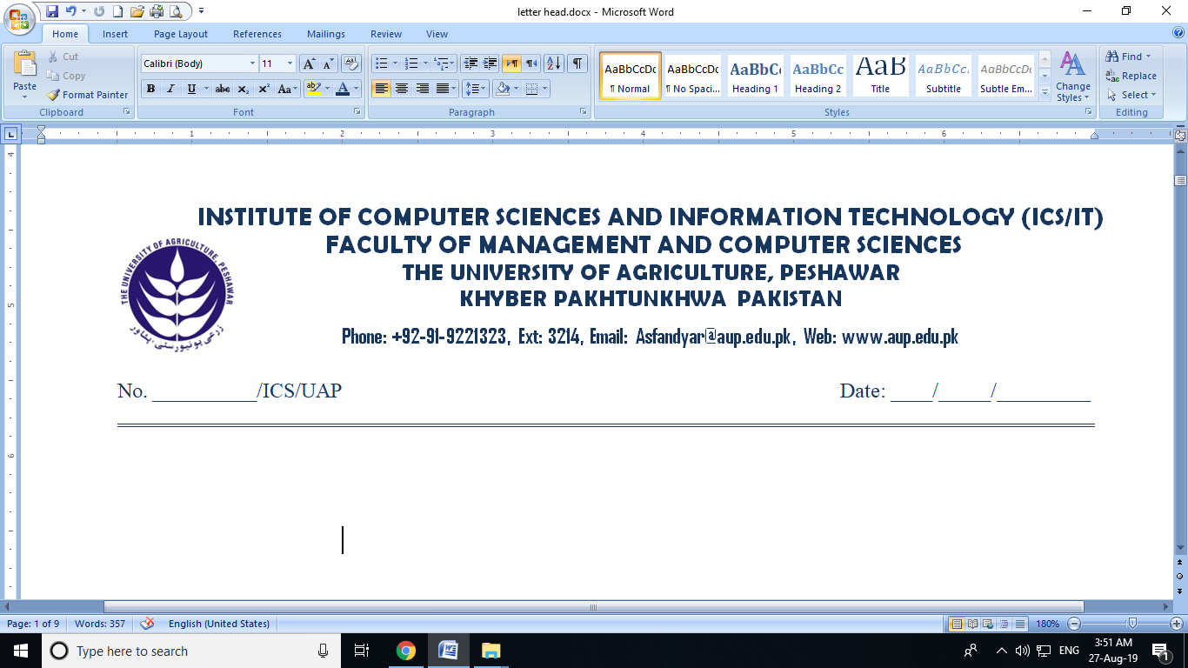

**BOS THESIS CORRECTION CERTIFICATE**

It is certified that Mr. /Miss. ___________________________ student of MS_______ under Class No ________ Session ________________has corrected his / her thesis as according to the minutes of board of study (BOS# ______ ) held on _____/____/______.

**Chairman Supervisory Committee**

**Correction Endorsement Committee:**

Name: ____________________________ Signature: __________________

Name: ____________________________ Signature: __________________

**Incharge / Coordinator**

**Post-Graduate ICS/IT (FMCS)**

**___________________________________________________________________________**

* **The following documents will be attached:**

1. Check List Performa Available (aupcsit.web.app)
2. Photocopy of current semester Registration Form with Bank Slip.
3. Thesis Charges Deposit Slip(Original)
4. Time Barred Notification and Fee Slip (if any)
5. Approved Correction Certificate (Signed by Endorsement Committee & Major Supervisor) and Inchage ICS/IT according to BoS Minutes. (available aupcsit.web.app)
6. Minutes Thesis BOS meeting. (available Dealing Assistant)
7. Photocopies of SSC, HSSC, Bachelors, Masters (DMCs & Certificates) MS Passed DMCs Attested.
8. Research Paper/Manuscript Submission Signed Major Supervisor .(Sarhad Journal of Agriculture Office (SJA)
9. Rough Plagiarism Certificate to Project Title Name + Supervisor Name +Student Name & Roll No.

(duly signed by Major Supervisor) bind at the end of each copy.